**Assignment1**

1. **Quick mask –** quick mask is tool that used to edit some portion you don’t want or also used to cut that portion to used in another area.

you can use the q as a shortcut of the quick mask mode or you simply use the the quick mask icon that is in the left side at the bottom.

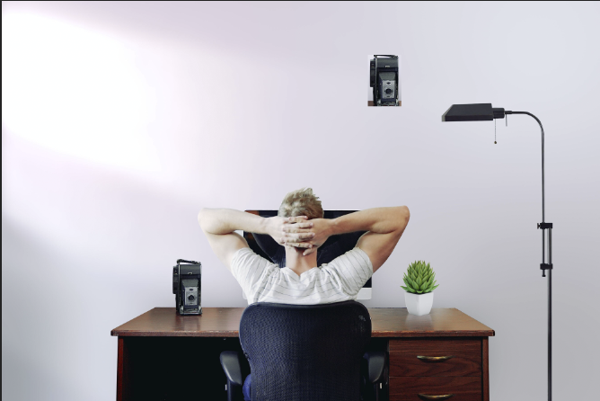

1. **Clipping mask-** the clipping mask is the group of layers in which the base layer have visible boundaries and the another layer will be the text or something like shapes.

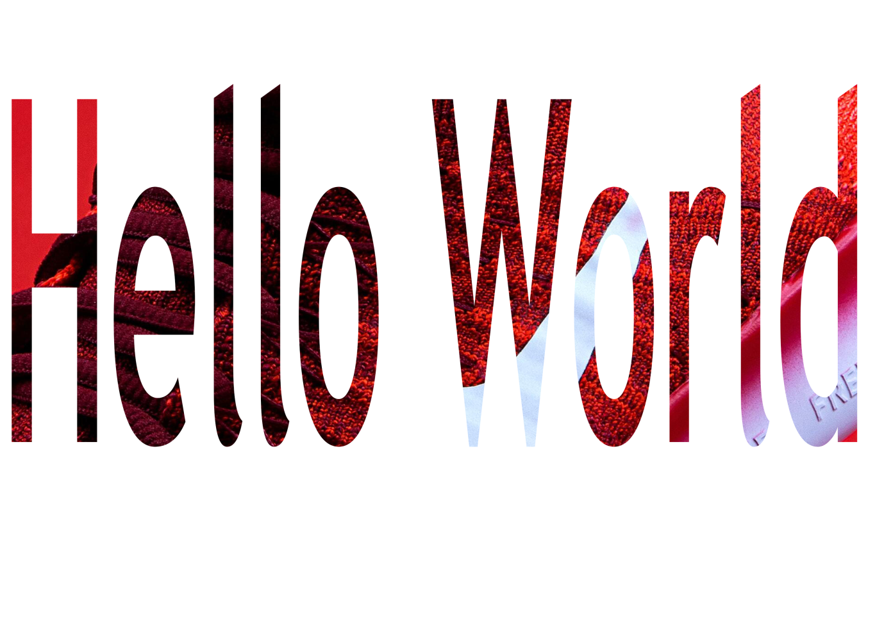

1. **Vector mask-**A vector mask is a resolution independent path that clips out the contents of the layer. Vector masks are usually more accurate than those created with pixel-based tools. You create vector masks with the pen or shapes tools. For more information on working with the pen or shapes tools, see Drawing.

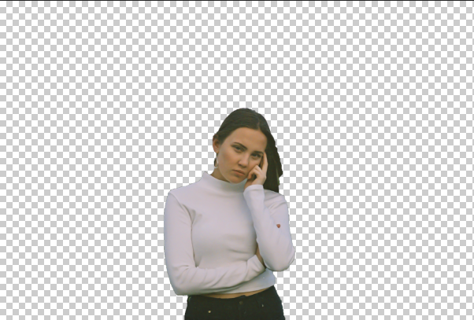

1. **Layer mask-**layer mask is tool to used to hide or reveal the part of layer .it is more effective and more easy way to use which gives more flexibility than deleting the part of layer.

